**Sorting and filtering a report**

**Introduction**

In this lesson on report navigation, you’ve gained insights into report hierarchies, drillthrough, sorting and filtering data, and cross-filtering and cross-highlighting. You will now have an opportunity to put some of your newly gained knowledge into action and apply it in a hands-on activity.

**Activity**

Your task is to open the given report and apply filtering and sorting to help the marketing stakeholders at Adventure Works make more informed data-driven decisions. To complete this activity, you need to:

* Open the existing marketing report in Power BI Desktop.
* Sort the ribbon chart in chronological order.
* Apply filters so that the ribbon chart and table chart display results for shipped orders only.
* Sort the line chart by the number of leads in ascending order.
* Sort the table and stacked column chart by region in ascending order.
* Make the stacked column chart and line chart display leads from Facebook and Google only.
* Display marketing data in the table for Facebook and Google only.
* Save the report for future use.

This screenshot that follows provides a visual representation of what your report will look like after successfully completing the tasks outlined in this activity.

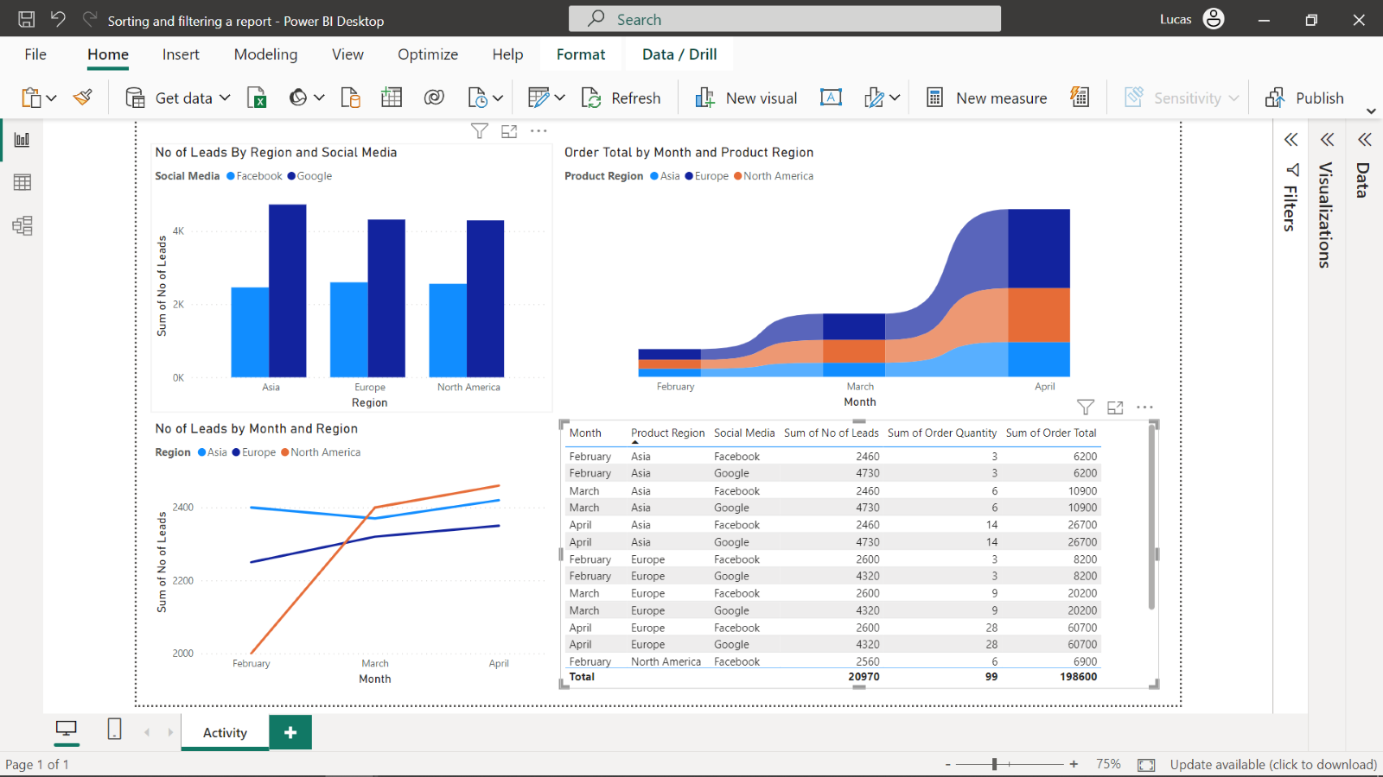

**Instructions**

Before starting the activity, you need to download the existing Power BI report from the marketing team at Adventure Works, *Sorting and filtering a report.*

[Sorting and filtering a report](https://d3c33hcgiwev3.cloudfront.net/18UQLQ2ZTcml9P7PxEMsvA_0b2299cfb8b044b08bee058dbfe1c3e1_Sorting-and-filtering-a-report.pbix?Expires=1737936000&Signature=HlCXFi~SSwMoO3nN2dXtXg2OkaWBkAopSHKSkIaPxiLDX~V0W7~Im0TAPq~MEYxvDwYPqvdzW2jhzVJ9sWipzkLbrOUEg6jJMwa9dtXMEPzEElzDCQHEZQTYGWQif8plFrc8kZ9tFUfYsT7o9zfOL2ac97GnDJ0wa~6PsYEOWUg_&Key-Pair-Id=APKAJLTNE6QMUY6HBC5A" \t "_blank)

[PBIX File](https://d3c33hcgiwev3.cloudfront.net/18UQLQ2ZTcml9P7PxEMsvA_0b2299cfb8b044b08bee058dbfe1c3e1_Sorting-and-filtering-a-report.pbix?Expires=1737936000&Signature=HlCXFi~SSwMoO3nN2dXtXg2OkaWBkAopSHKSkIaPxiLDX~V0W7~Im0TAPq~MEYxvDwYPqvdzW2jhzVJ9sWipzkLbrOUEg6jJMwa9dtXMEPzEElzDCQHEZQTYGWQif8plFrc8kZ9tFUfYsT7o9zfOL2ac97GnDJ0wa~6PsYEOWUg_&Key-Pair-Id=APKAJLTNE6QMUY6HBC5A" \t "_blank)

**Step 1: Open the report file in Power BI Desktop.**

* Select the **File** menu, followed by **Open Report** and the *Sorting and filtering a report* file.

**Step 2: Sort the ribbon chart in chronological order**

1. Select the ribbon chart, then the three dots on the top right corner of the visual.
2. Select **Sort axis**, then **Month**, then **Sort ascending**.

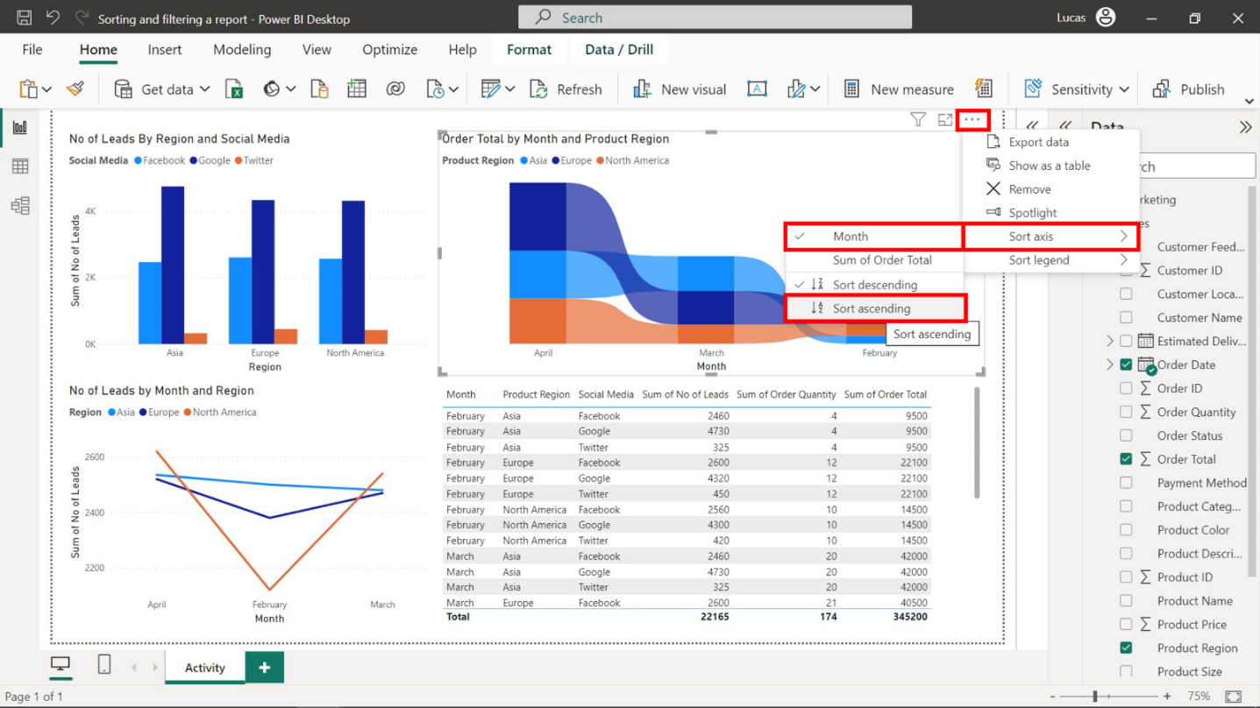

**Step 3: Apply filters so the ribbon and table charts display results for shipped orders only.**

1. Select the ribbon chart and open the **Filters** pane.
2. Drag the **Order Status** field from the **Data** pane to the **Add data fields here** box in the **Filters on this visual** section.
3. Check **Shipped** in the **Order Status** filter.

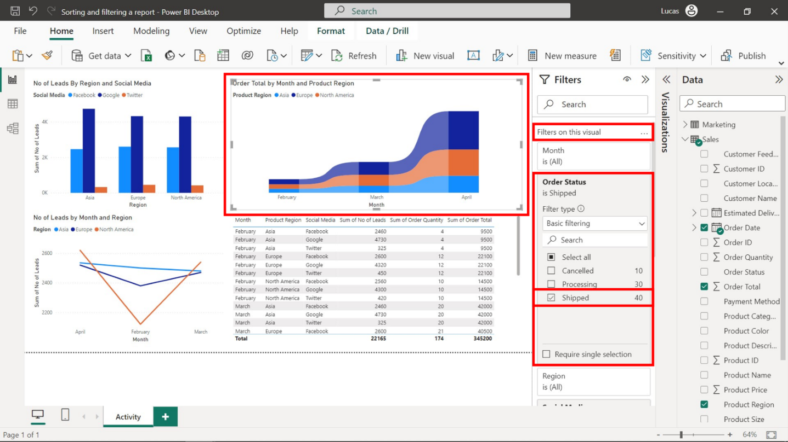

1. Select the table chart and open the **Filters** pane.
2. Apply the same process to the table chart.

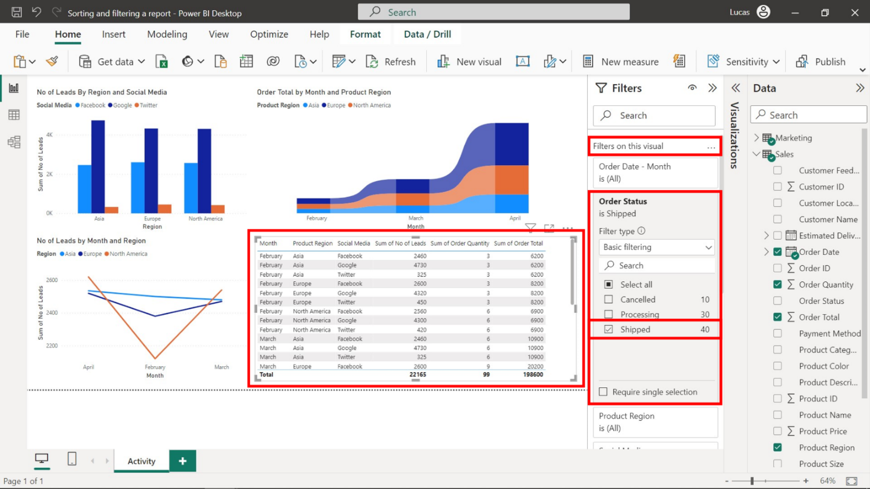

**Step 4: Sort the line chart by no of leads in ascending order.**

1. Select the line chart and then the three dots in the top right corner of the visual.
2. Select **Sort axis**, then **Sum of No of Leads**, then **Sort ascending**.

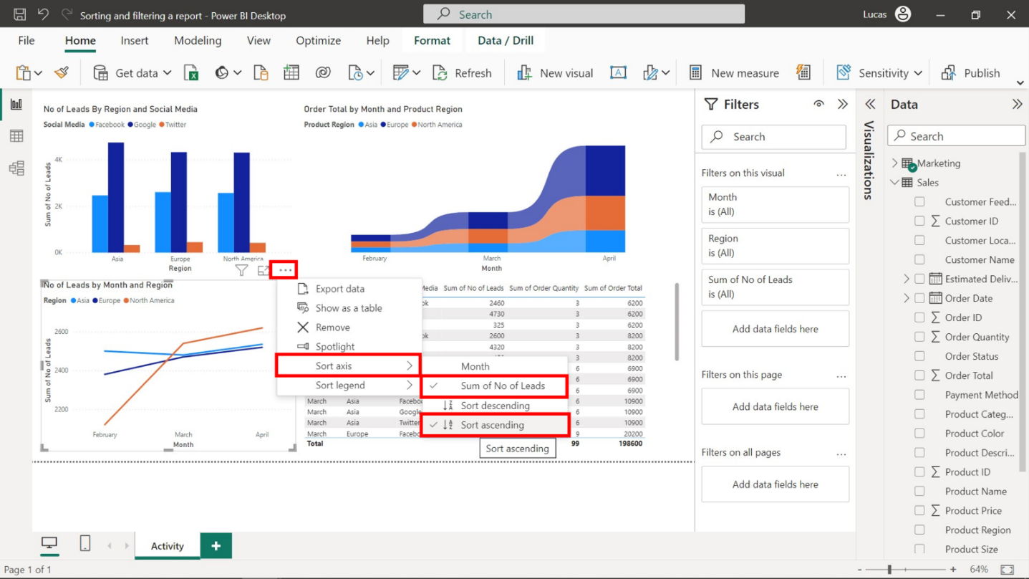

**Step 5: Sort the table and stacked column chart by regions in ascending order.**

1. Select the stacked column chart, followed by the three dots in the top right corner of the visual.
2. Select **Sort axis**, then **Region**, then **Sort ascending**.

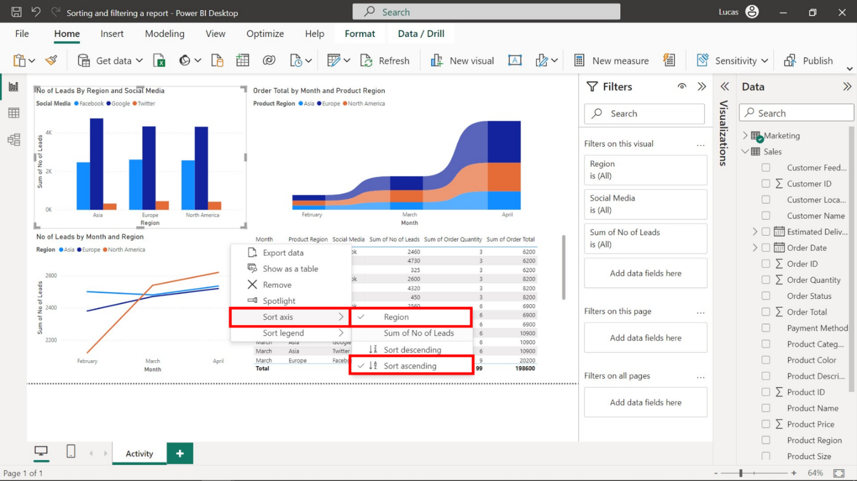

1. Next, select the table visual, then the **Product Region** column title. Make sure the arrow sign under this column title is pointing upward.

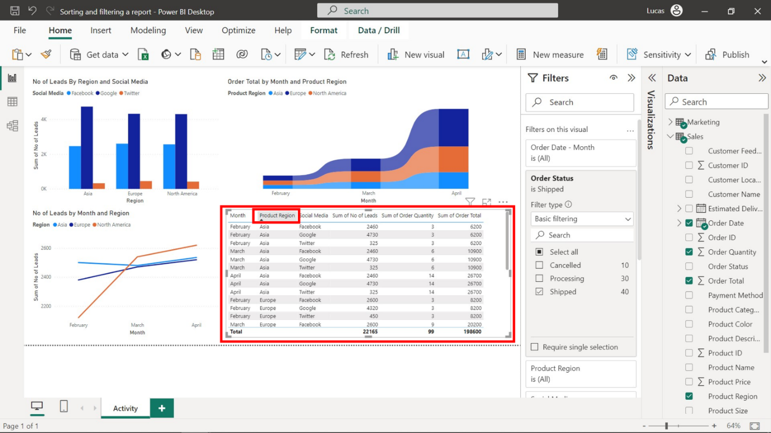

**Step 6: Filter the stacked column and line charts to display leads from Facebook and Google only.**

1. Select the stacked column chart and open the **Filters** pane
2. Drag the **Social Media** field from the **Data** pane to the **Add data fields** here box in the **Filters on this visual** section.
3. Check **Google** and **Facebook** only.

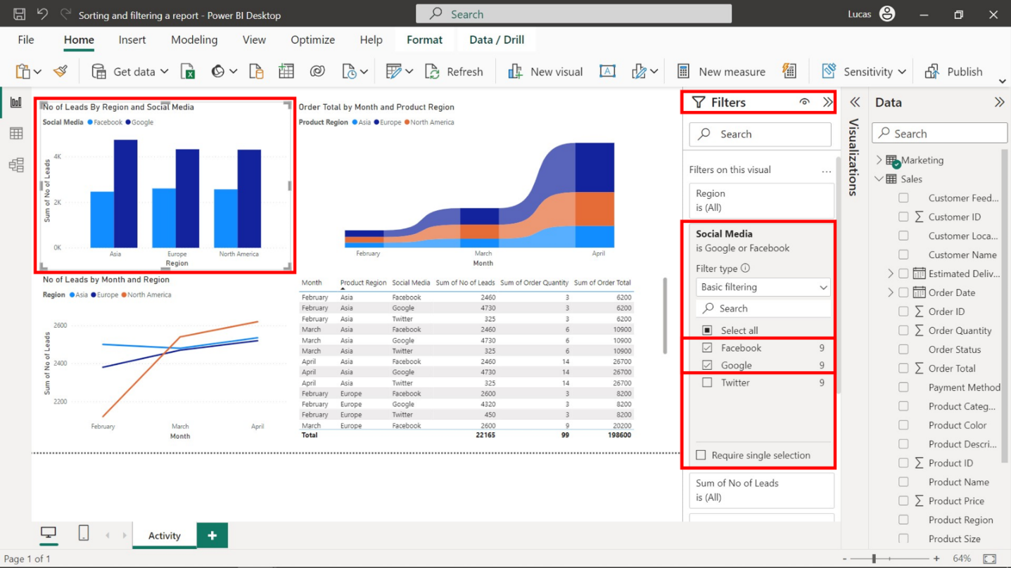

1. Select the line chart and open the **Filters** pane.
2. Apply the same process to the line chart.

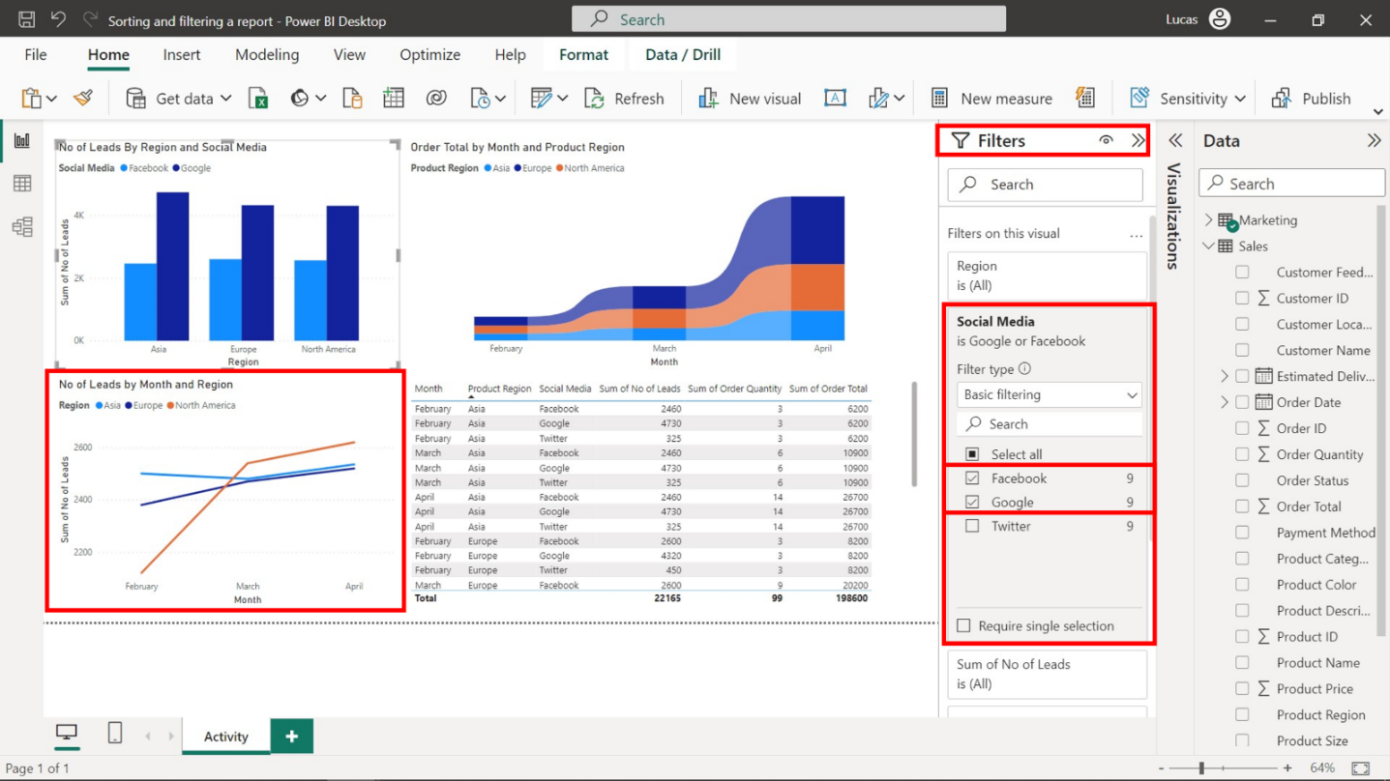

**Step 7: Display marketing data in the table for Facebook and Google only.**

1. Select the table visual and open the **Filter** pane.
2. Drag the **Social Media** field from the **Data** pane to the **Add data fields here** box in the **Filters on this visual** section.
3. Check **Google** and **Facebook** only.

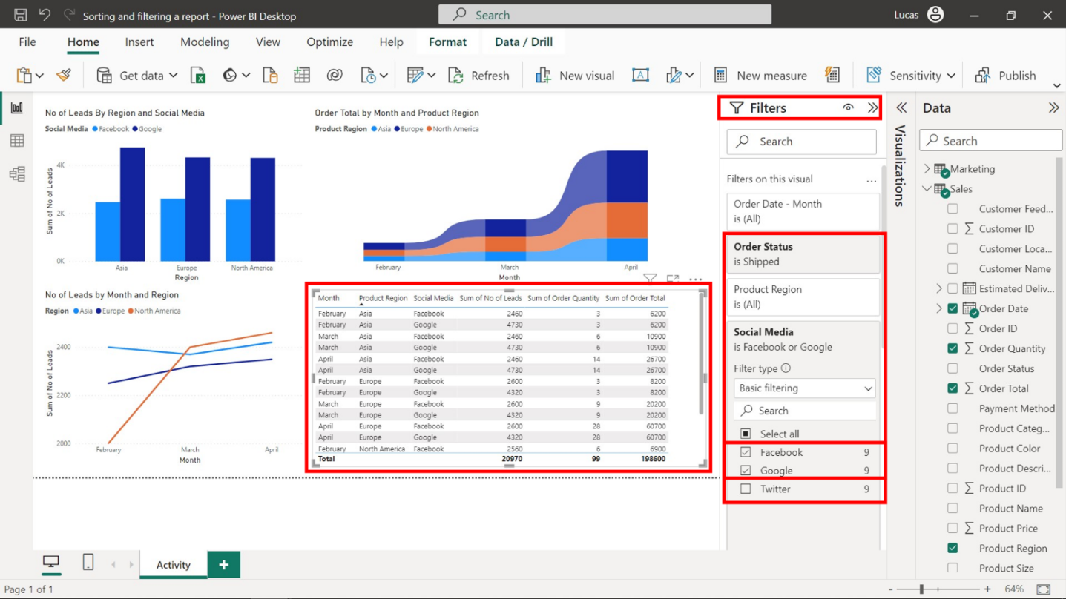

**Step 8: Save the report for future use**

* Once all the changes have been made, save the report by opening **File** menu and selecting **Save**.

**Conclusion**

By completing this activity, you have gained insight into the impact and importance of sorting, filtering, and refining data within a report for driving informed decision-making. By practicing using and applying report navigation techniques like sorting and filtering in Power BI, you will become increasingly proficient at shaping data into meaningful insights for stakeholders.